2025 World Aviation Conference – Booth Application Form

■ Exhibitor Information
Company Name
Address
Representative
Contact Person | Name |  | Title |  | Dept.
 | Email
Exhibited Products

■ Booth Application Details
Provided | Standard Booth
Preferred Booth Location | 1st Priority |  | 2nd Priority |  | 3rd Priority
* Refer to Attachment 1, 2 for booth specifications and layout.

■ Notes
• Booth allocation may close early.
• If your preferred location is not available, an alternate location may be assigned.
• All other compliance matters are following the Exhibition Regulations (Attachment 3).

We agree to comply with the participation rules and hereby apply as stated above.

2025. . .

Company Name:
Representative: (Signature)

Attachment 1: Standard Booth Specification
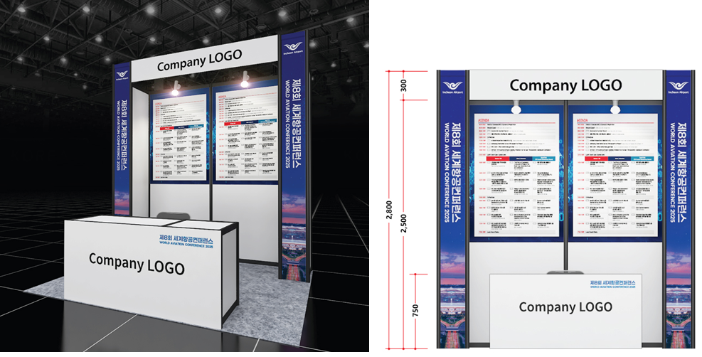
Space | 2.5M X 2M
Booth Size | 2.5M X 2M X 2.5M(H)
Type | Basic Modular Booth
Provided | 1 information desk, 2 chairs

*For additional items such as printed materials, TVs, or furniture, please contact the WAC 2025 secretariat.

[ WAC 2025 Secretariat ]
E-mail : 2025wac@gmail.com
Phone : +82-2-550-2548

Attachment 2: Booth Layout

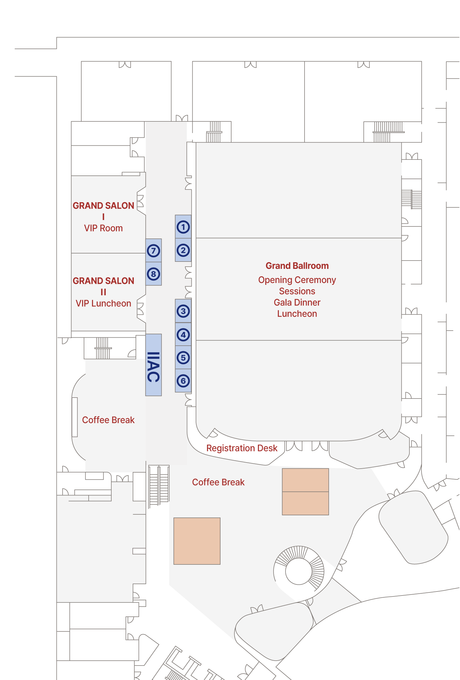

Attachment 3: Exhibition Regulations

Article 1 (Definitions)
1. "Participant" refers to any company, institution, etc. that has submitted an application form for the installation and operation of an exhibition booth.
2. "Exhibition" refers to the "2025 World Aviation Conference."
3. "Organizer" refers to the "Secretariat of the 2025 World Aviation Conference."

Article 2 (Application for Booth Participation)
1. Anyone wishing to apply for an exhibition booth must complete and submit the application form to the organizer. Submission of the application form is considered confirmation of participation.
2. However, if all exhibition booths are fully booked or if the items intended for display are deemed inappropriate for the exhibition, the organizer may refuse the application.

Article 3 (Booth Assignment and Modification)
1. Booths will be allocated by the organizer based on the order of application, booth size, and exhibition items.
2. The organizer may change the assigned booth location if necessary to ensure the overall spatial harmony, visitor flow, and exhibition effectiveness.
3. Such changes are at the discretion of the organizer, and participants may not claim compensation for the result of such changes.

Article 4 (Cancellation of Participation and Exhibition)
1. If a participant wishes to cancel their booth use, they must immediately notify the organizer in writing.
2. However, cancellations are not allowed within 30 days of the exhibition opening date.
3. In the event the exhibition is canceled or postponed due to unavoidable circumstances not attributable to the organizer (e.g., natural disasters), the organizer shall notify the participant in writing, and participants may not claim compensation based on incurred expenses.
Article 5 (Booth Operation and Use Guidelines)
1. Participants must exhibit only the items specified in their application and assign on-site staff to manage their booths diligently.
2. If a participant exhibits unauthorized items, inappropriate items, or conducts direct sales without prior approval, the organizer may order immediate suspension, removal, or disposal of such items. No compensation shall be granted in such cases.
3. Participants may not transfer, resell, or exchange their assigned booth space without official consent from the organizer.
4. Participants may not alter or damage the exhibition hall or equipment during installation, exhibition, or dismantling. Any damage must be repaired and compensated appropriately.
5. Participants must notify the Organizer of the expected amount of electricity required for the Exhibition no later than 10 business days before the event. They must also take all necessary precautions to ensure that no issues arise from electrical equipment during the Exhibition.

Article 6 (Liability for Damage, Theft, and Insurance Requirements)
1. Participants are fully responsible for damage or theft of exhibit materials and equipment within their designated booth areas during the exhibition and installation/dismantling periods.
2. If a participant causes fire, theft, damage, or other accidents due to intent or negligence, they shall bear full liability for compensation. Insurance coverage for exhibited items is the participant's responsibility.

Article 7 (Fire Safety and Prohibited Activities)
1. All materials used in installations and inside the exhibition hall must be nonflammable in accordance with fire regulations. Cooking or the use of electric heating devices is prohibited.
2. The organizer may require participants to make fire-prevention corrections as needed.

Article 8 (Exhibit Display and Noise Restrictions)
1. When bringing in and setting up exhibits, Participants must take appropriate measures, such as protective coverings, to prevent damage to the floor and carpets.
2. Noise must not exceed 65 dB measured at 1 meter from the noise source.

Article 9 (Cleanliness and Waste Disposal)
1. The organizer will ensure general cleaning of the exhibition space during the exhibition period.
2. However, participants are responsible for removing waste generated during booth installation/removal. If waste is left behind, participants shall reimburse the organizer for any disposal costs incurred.

Article 10 (Move-In and Move-Out of Exhibition Items)
1. Participants must move in/out all exhibits and equipment within the period specified by the organizer. Any costs arising from delays shall be borne by the participant.

Article 11 (Consent for Use of Personal Information and Image Rights)
1. The organizer collects personal information provided in the application form and uses it solely for purposes such as promoting future exhibitions, confirming participation, and providing notices. All data will be destroyed after use.
2. Participants and their personnel are deemed to consent to the use of their image in photos and videos taken during the exhibition for promotional purposes.
3. Image use is limited to promotional materials (printed, video, website, newsletter, social media) and will be valid for up to two years after the exhibition ends.

Article 12 (Supplementary Provisions)
1. If necessary, the organizer may establish supplementary regulations not specified in these guidelines and shall notify participants of such changes.

